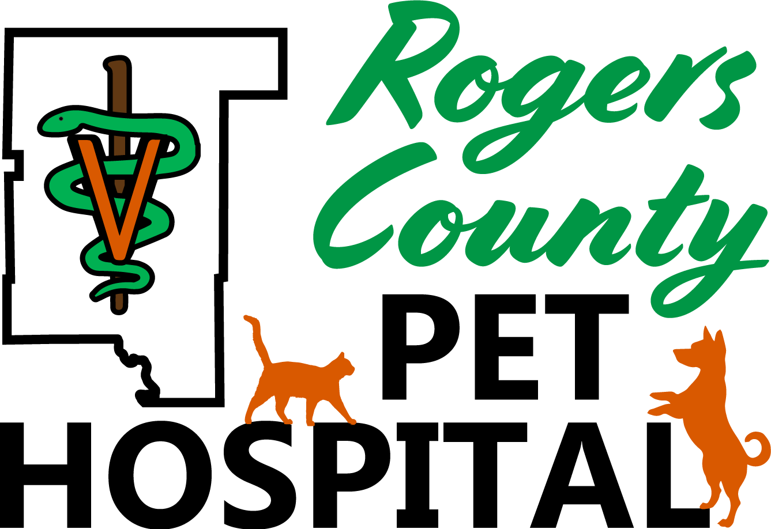

New Client/Patient Registration Form

Welcome to Rogers County Pet Hospital! Thank you for giving us the opportunity to care for your pets. Please read and fill out this form completely so that we may better serve you.

Date: _______________________
Name: __________________________________ Spouse/Co-Owner:____________________________
Address: _____________________________________ City/State/Zip: __________________________
Phone #s Home: ____________________ Cell:_____________________ Work:_________________
E-mail(s): ______________________________________________________________________________
What is the best form of contact for you? Home # Cell # Work # Email
How did you learn of our hospital? Yellow Pages Office Sign Billboard Internet
Facebook Referral (who may we thank?)_______________________________
Other person(s) authorized to order treatment or obtain information (optional)
Name: ____________________________________ Phone #:_______________________________
Address: ___________________________________ City/State/Zip: _________________________
Please list all of your pets we are seeing today.
Name | Species | Breed | Color | DOB or  Age | Sex | Spayed or Neutered? | Indoor/Outdoor
Have you taken your pet(s) to a veterinarian before? Yes No If yes, where? May we obtain previous records? _________________________________
Any previous serious illnesses or surgeries? _____________________________________________________________
Any known allergies? _________________________________________________________________________________
Is your pet on any medications (including flea/tick/heartworm prevention)? __________________________________
Current diet (please include treats & supplements):________________________________________________________
____ I authorize Rogers County Pet Hospital to post pictures of my pet on their website & social media pages.
AUTHORIZATION/CONSENT TO RECEIVE AND PAY FOR SERVICES
All fees are due at the time services are rendered
We are pleased to accept: Cash, Check, Visa, Mastercard, Discover, Care Credit, and Scratchpay

I, the undersigned, assume responsibility for all charges incurred in the care of my animals. I also understand that all charges will be sure and paid at the time such services are performed.

Owner Signature: _______________________________________ Date: ________________

