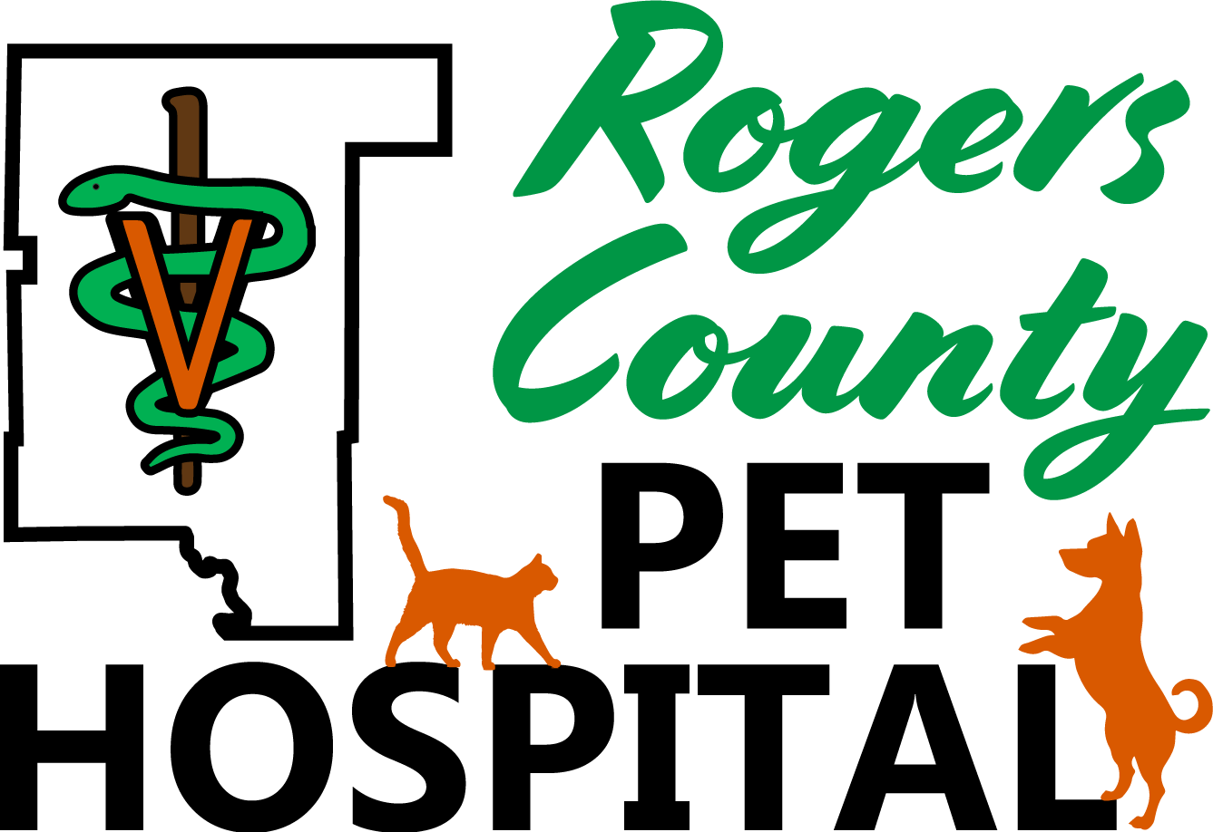

Boarding Information Sheet

Owner’s Name: <first-name> <last-name> Phone Number: <area> <phone>
Pet's Name: <animal> Date of Admission: __________ _
Pet Color: <color> Discharge Date: ______________
Emergency Name and Number:______________________________________________________________________
Rogers County Pet Hospital Boarding Requirements
- All pets admitted to the hospital must be free of external parasites. If not, treatment will be performed at the owner’s expense.
- All boarding pets will receive an internal parasite exam. For those pets that test positive for internal parasites, treatment will be given at the owner’s expense (weight dependent).
- All pets admitted to the hospital must be protected via current vaccination against communicable contagious diseases.
  - If vaccinations were performed elsewhere, it is the owner’s responsibility to provide written documentation of all required vaccinations administered by a licensed veterinarian prior to the scheduled boarding reservation.
  - If proof of vaccination is not provided prior to the scheduled boarding reservation, an exam and the required vaccinations will need to be administered during the pets stay and at the owner’s expense.
- There may be an additional fee for pets deemed aggressive or requiring extra caution or care during the boarding period.
- Boarding fees are per night: Canine - $24.00 Feline - $17.00
- Boarding fees will be due at time of Drop Off.

Instructions While Boarding

Feeding: Hospital Food AM Dry:____________cup(s)
Special Diet/Own Food PM Wet:____________can(s)

Add-ons: □ Bath $15 □ Extra playtime $5 □ Composure Chews $.50-$1 □ Peanut Butter Kong Toy $3 □ Lean Treats (4 oz) $6 □ Yummy Comb $5 Qty: ______
Special Instructions:_____________________________________________________________________

Medications and Instructions (up to $5/day): ____________________________________________________________

Please list any procedures you would like done during the boarding period:___________________________________

_________________________________________________________________________________________________

For Hospital Use Only --
Cats Dogs
Current Update While Boarding Current Update While Boarding □ FVRCP □ □ DHLPP □
□ Bordetella □ □ Bordetella □
□ Rabies □ □ Rabies □
□ Fecal □ □ Fecal □
□ HWT □

Owner Release for Boarding - Please read carefully!
I understand you cannot guarantee the health of my pet. I understand and will not hold the hospital responsible for conditions that are unavoidable in boarding kennels, such as but not limited to weight loss, hair loss, upper respiratory infections, bronchitis, and diarrhea. I understand that the hospital is not responsible for loss or damage to personal items left with the pet including but not limited to leashes, collars, toys, and bedding.

I understand ALL pets admitted to the hospital must be vaccinated against communicable contagious diseases and must be free of internal and external parasites or will be treated on entry or discovery at the owner’s expense.

I understand that in the event of my pet’s illness, the staff will immediately attempt to contact me or my agent to discuss the problem and treatment options but may not be able to contact me immediately and is therefore authorized to initiate appropriate treatment until myself or my agent can be reached.

Should an EMERGENCY arise, I authorize the medical staff to sedate my pet and/or perform such emergency procedures as may be necessary for the health of my pet until I can be notified. I agree to pay, in full, all charges for necessary services rendered for and to my pet.

I understand that any problem that develops with my pet will be treated as noted below and I assume full responsibility for the treatment expenses incurred.

If any problem is observed or develops:

- Please treat my pet as required, you need not call me.
- Please perform the recommended diagnostics and/or treatments so long as the additional amount does not exceed $___________
- Do NOT perform any diagnostics and/or treatment until I am notified and consent for you to evaluate and treat as recommended.
- DNR: DO NOT perform any life-sustaining measures.

I further agree that I, or an authorized agent of mine, will pick up my pet and pay for all accrued charges on the scheduled pick-up date. I will call if my pick-up date changes so you can plan accordingly. If I neglect to pick up my pet within 3 days of the date scheduled for discharge, and do not notify you within that time period, you may assume that the pet is abandoned and are hereby authorized to dispose of the pet as you deem best and/or necessary.

All requirements and fees are for the protection of your pet, the other animals boarding here, and our staff. These terms are non-negotiable and we reserve the right to deny our boarding services upon refusal of these terms.

______ I authorize ROCO Pet Hospital to post pictures of my pet on their website & social media pages.

Owner / Agent Signature: ____________________________________ Date: __

Rogers County Pet Hospital
1201 N. Lynn Riggs Blvd.
Claremore, OK 74017
(918) 341-5551

